SIA "GRAVITIS ENTERPRISE LIMITED"
Lauku iela 7 - 4, Cēsis, LV-4101, Latvia

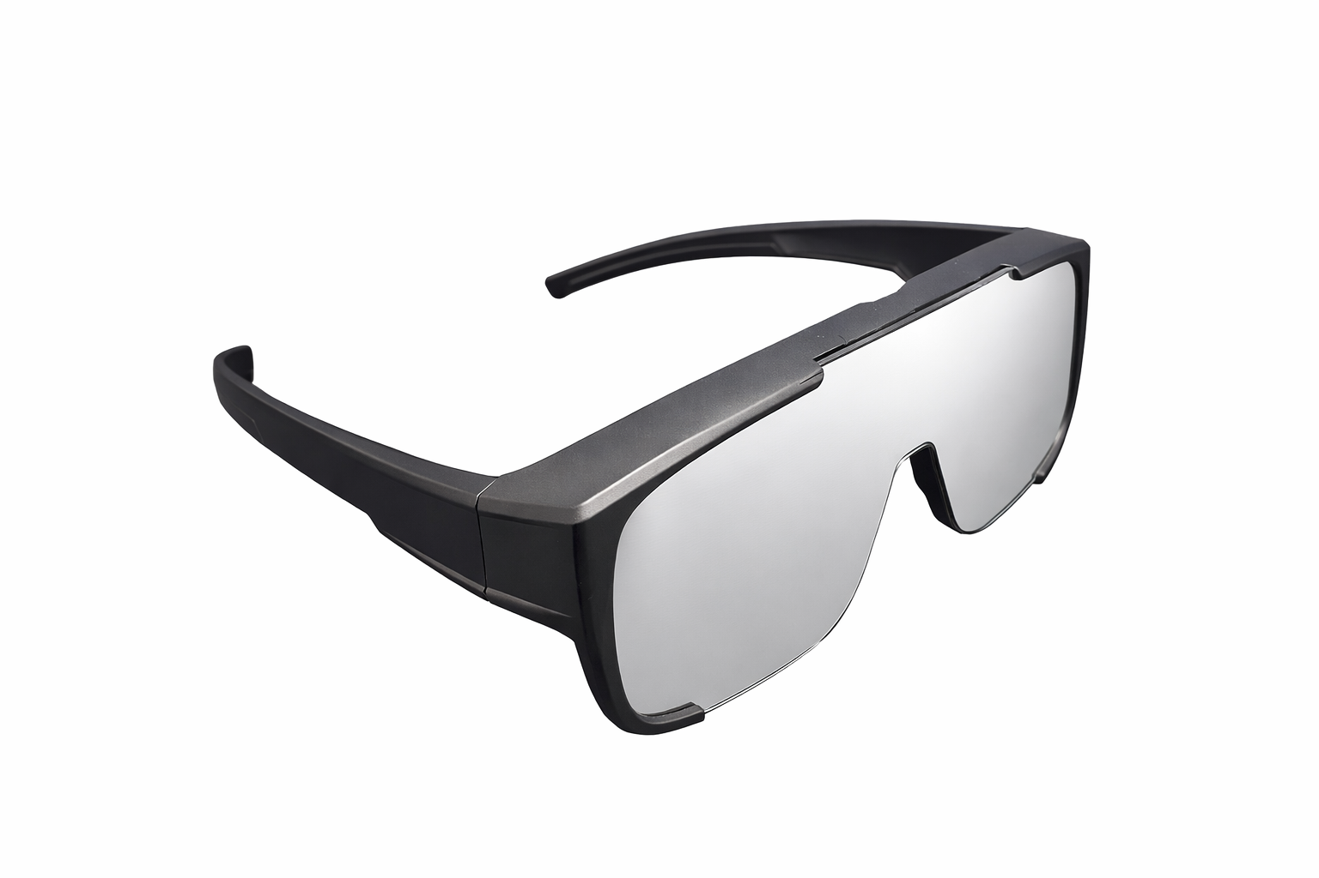
Technical Drawing Package

Solar Eclipse Plastic Glasses (EGP-FIT-TDP)
Document Title: | Technical Drawing Package
Product | Solar eclipse glassses. Model: EGP-FIT-TDP
Document No.: | EGP-FIT-TDP-001
Revision: | A
Date: | 5/2/2026
Status: | FOR NOTIFIED BODY SUBMISSION

 |   Name | Signature | Date
Drawn By: | Māris Grāvītis |  | # TODO
Checked By: | Māris Grāvītis |  | # TODO
Approved By: | Māris Grāvītis |  | # TODO

Table of Contents
Revision History 2
Fabrication Specification (EGP-FIT-FAB-001) 3
SPECIFICATION DATA 3
MANUFACTURING & QUALITY NOTES 4

Revision History

Revision | Description Of Changes | Date | Approved By
A | Initial Release | 05/02/2026 | Māris Grāvītis

Fabrication Specification (EGP-FIT-FAB-001)

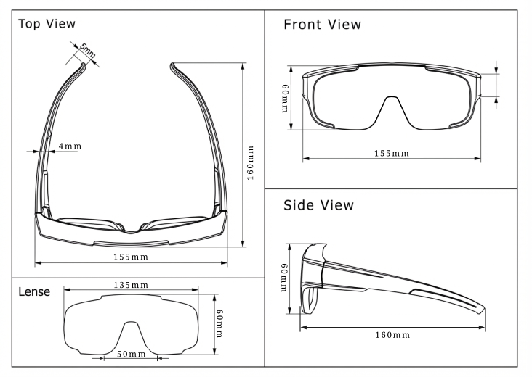
SPECIFICATION DATA
Parameter | Specification
Product Model | EGP-FIT (Oversized Fit-Over)
Standard | EN ISO 12312-2:2015 (PPE Category II)
Frame Material | Injection Molded Polypropylene (PP)
Filter Material | Silver-Black Polymer (0.12mm nominal)
Optical Density | OD ≥ 5.0 (Transmittance ≤ 0.0032%)
Protection | 100% UV / 100% IR Block

MANUFACTURING & QUALITY NOTES
- LIGHT LEAKAGE (CRITICAL): 100% inspection required. There must be zero light leakage around the perimeter where the filter meets the frame.
- LENS RETENTION: Filter lenses must be securely retained. Any loose lenses are a critical failure.
- SURFACE QUALITY: Filter surface must be free from pinholes, scratches, or delamination.
- MARKING: Due to the specific nature of the surface/production, no markings are applied directly to the product. All mandatory regulatory markings (CE, Notified Body No, Manufacturer, Standard) are applied to the Primary Packaging. (See Packaging Artwork: PKG-PLASTIC-SERIES-1PK-OUTER-001).

